Géneros de video Juegos

Género

Acción



Wing Fighter

MINIGAME ENTERTAINMENT LIMITED

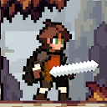

Apple Knight: Action Platformer

Limitless, LLC



Mahjong by Microsoft

Microsoft Corporation



Mario Kart Tour

Nintendo Co., Ltd.



Shadow of Death: Dark Knight

Bravestars Games



World War 2 - Battle Combat (Juegos de pistolas)

Edkon Games GmbH

Arcade



Jewels Legend - Match 3 Puzzle

LinkDesks - Jewel Games Star



AirAttack 2 - WW2 Airplanes Shooter

Colya



Gameloft Classics: 20 años

Gameloft SE



Smash Hit

Mediocre



Sonic The Hedgehog 2 Classic

SEGA



Sky Force Reloaded

Infinite Dreams

Aventura



The Frostrune

Snow Cannon Games



New York Mysteries (free to play)

FIVE-BN GAMES



LOST in Blue (Global)

Volcano Force



Oddmar

Mobge Ltd.



Life is Strange

SQUARE ENIX LTD



The Legacy: Forgotten Gates (free-to-play)

FIVE-BN GAMES

Carreras



Asphalt 9: Legends

Gameloft SE



Gear.Club - True Racing

Eden Games



Rebel Racing

Hutch Games



Beach Buggy Racing 2

Vector Unit



Asphalt Nitro

Gameloft SE



Hill Climb Racing 2

Fingersoft

Cartas



Microsoft Solitaire Collection

Microsoft Corporation



Spider Solitaire

MobilityWare



Magic: The Gathering Arena

Wizards of the Coast LLC

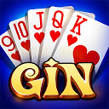

Gin Rummy

Teen Patti Rummy Ludo by Banyan



Card Party - UNO Juego de Cartas

Bombay Play - Card Games for Friends and Family

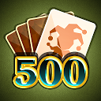

Rummy 500

North Sky Games

Casino



DoubleU Casino - Free Slots

DoubleUGames

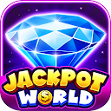

Jackpot World™ - Slots Casino

SpinX Games Limited

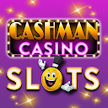

Cashman Casino - Tragaperras

Product Madness



Tragaperras Lightning Link

Product Madness

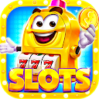

Jackpot Master™ Slots

Jackpot Master Casino

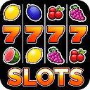

Slot machines - Casino slots

TINYSOFT - slots, slot machines & casino games

Casual



Mi Talking Tom: Amigos

Outfit7 Limited



Zen Koi 2

LandShark Games



Piggy GO - Clash of Coin

Forever9 Games



SpongeBob: Krusty Cook-Off

Tilting Point



Food Truck Chef™ Juegos Cocina

Nukebox Studios



Royal Farm: La Vida del Pueblo

UGO Games

Deportes

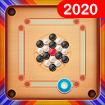

Carrom Friends : Carrom Board Game

Yoozoo Global



Golf Master 3D

Doodle Mobile Ltd.



Pro 11 - Online Football Manager

Trophy Games - Football Manager makers

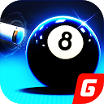

Billar 3D

Giraffe Games Limited



Soccer Star 2021 Top Ligas: Mejor juego de fútbol

Viva Games Studios



Top Football Manager - MÁNAGER DE FÚTBOL

Gamegou Limited

Educativos

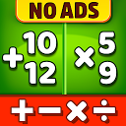

Juegos de matemáticas: suma, resta, multiplicación

RV AppStudios

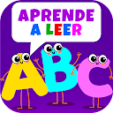

Aprender a leer Juegos educativos Juegos de letras

Bini Bambini



Inglés Fácil-English Course

EducUp



Aprender inglés para niños. Juego educativo Fixies

1C-Publishing LLC



Aprende japonés gratis con kawaiiNihongo!

MardukCorp



MentalUP - Juegos Educativos & Juegos Mentales

Ayasis

Estrategia



Defense Legend 4: Sci-Fi Tower defense

Gcenter



World War 2: Strategy Games WW2 Sandbox Tactics

Joynow Studio



The Ants: Underground Kingdom

StarUnion

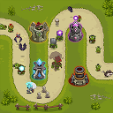

Rey de la torre de defensa

mobirix



Dawn of Titans: RPG de estrategia bélica

NaturalMotionGames Ltd



Alien Creeps TD

Outplay Entertainment Ltd

Juegos de mesa



Mahjong Epic

Kristanix Games



Learn Chess with Dr. Wolf

Chess.com

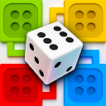

Ludo Party: juego tablero

Miniclip.com



Ajedrez - Chess Stars

Coffee Break Games



Damas

English Checkers



Ludo Talent - Game & Chatroom

Indigo Technology Pte. Ltd.